
Wiltshire Community Web Online Newsletter

April 2007

Hello all and welcome to the fifth issue of the bi-monthly Wiltshire Community Web Online Newsletter.
1 year old this month!

Training Events Information

The first series of free training events has now been completed. The second will commence in the summer. These will be for both the new and advanced users of WCW.

All dates will be advertised in future newsletter issues and in the news and diary sections of www.wiltshirecommunityweb.org.uk – keep checking back!

If you are a group of people that are interested in finding out more about WCW, we could organise a group training session – get in contact!

Hints and Tips

Amending Site Categories and Title
(for Kennet/West Wilts/North Wilts areas only)

When sites are initially set up, categories are chosen so that the site will be picked up in the searches carried out using the Wiltshire Community Web search facility. Up to 3 categories can be chosen.
If at any point you wish to change these, you will need to login to modify your site and select ‘amend project title' from the administration page - here you can also amend the site title.
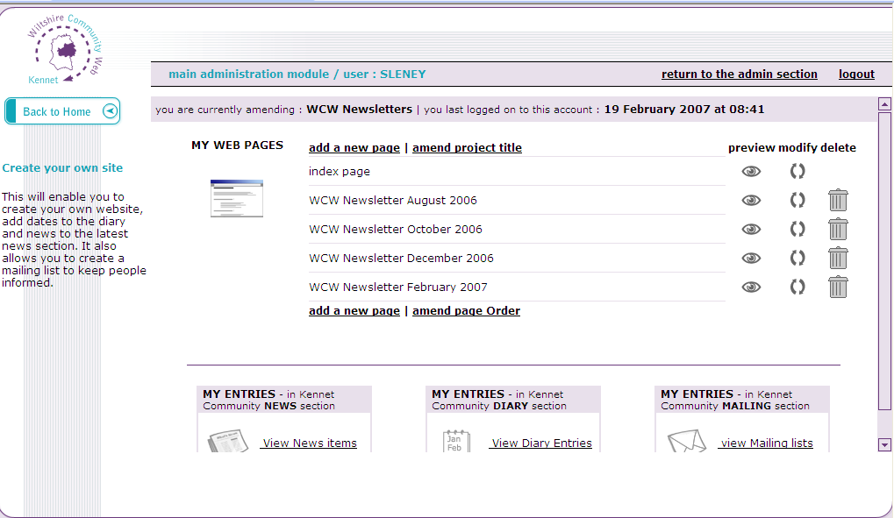

Main Administration Page

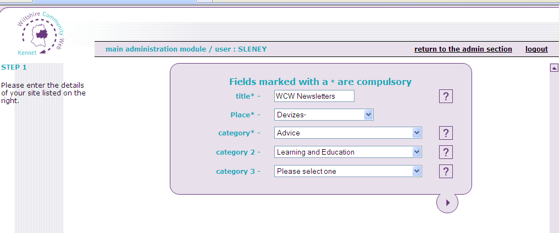

Mailing Lists

It’s an easy feature for you to enable on your website. Once set up, visitors to your site can opt to join your mailing list.

Using your main administration page you are then able to manage your mailing list and send out regular email bulletins or maybe an update about your site.

This can really help your group to promote your events and keep interested parties up to date with what you have been up to.
Take a look at lesson 8 of the WCW tutorials for further information

Spotlight on a Wiltshire Community Web Site

Dinton Village Hall

“Dinton Village Hall joined the southwilts area of the website as soon as we were invited and Steve Milton at Salisbury District Council kindly got us going.

Since its inception we have added to the photographs to give potential hirers a taste of what they can achieve for various functions. Although it is now six years since we opened, it is still in remarkably good order for a public building. With a large car park, full commercially fitted kitchen and ample space to dine up to 150 people we find we attract hirers from all round the county.

It is a great advantage to be able to tell them to have a look at
the website to get a feel of the building and save a visit. This also acts
as a great advert because it looks so good on the photographs.

Our income has grown year on year and we have just installed an overhead projector and large electrically operated overhead screen which will allow PowerPoint presentations and even a cinema type facility. With the new equipment, we hope to attract corporate users for conferences during the day as they are a good source of income.
The upkeep of the premises is shared by our part time caretaker and handyman
who looks after the inside and does some gardening and the Chairman and
Secretary who cut all the grass.”
Mike Glover
Visit the site on Wiltshire Community Web: http://www.southwilts.com/site/Dinton-Village-Hall/index.htm

Get your site noticed!

For each newsletter, we will feature a site that has been created on Wiltshire Community Web.

If you would like to have your site featured here in a future issue to promote your success, then get in touch!

Email us at info@wiltshirecommunityweb.org.uk with a short explanation of your site.

Editors Notes

Wiltshire Community Web is managed by Community First.

Community First is a charitable organisation that works at the forefront of community development to help improve the quality of life and economic well being of people and local communities throughout Wiltshire and Swindon

For further information visit our website at www.communityfirst.org.uk

Community First
Wyndhams
St Josephs Place
Devizes
Wiltshire
SN10 1DD Tel: 01380 722475 Fax 01380 728476
Registered Charity No: 288117
VAT Registration No: 639 3860 06
Company Limited by Guarantee Reg. No: 1757334 England
Registered with the Financial Services Authority No: FRN 311971

